Patrick Bondaruk

N00201161

DL836 Year 1

[Draw your reader in with an engaging abstract. It is typically a short summary of the document.   
When you’re ready to add your content, just click here and start typing.]

DL836 – CREATIVE COMPUTING  
Programming

Programming Continuous Assessment 2

Introduction

The programming project that I have chosen to make is an interactive gallery of TV Shows. The reason I chose it is because it was an interesting topic of gallery for me so I went for making it.

Design

I designed the gallery by just having a simple dark background and for each separate pages had a picture on left side of a specific TV show, and along on the right side is a title and a description of a TV show with a button on the far right side for playing the trailer.

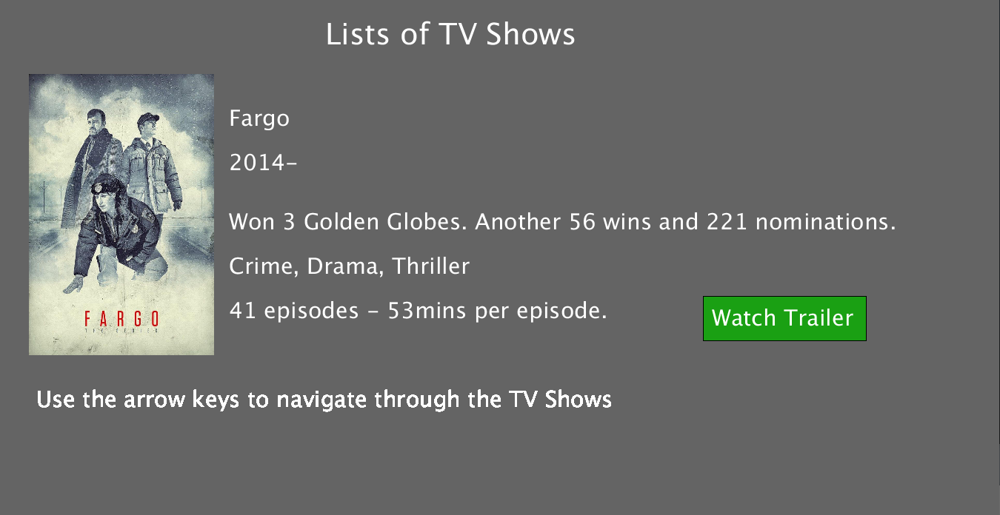

Implementation

I implemented the code by having different private classes in the Artefact tab to use each of them for a gallery page.

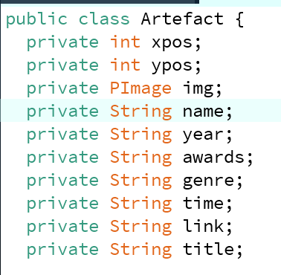

Then I implemented all the variables, either images or text into the public class to display everything in specific that I have implemented.

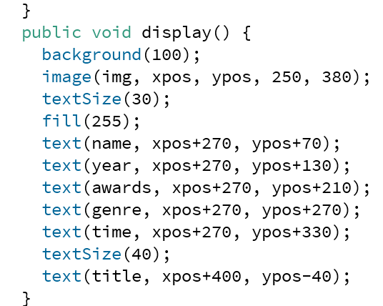

Then I implemented function for a button and had a link of a video that would lead to video for every page.

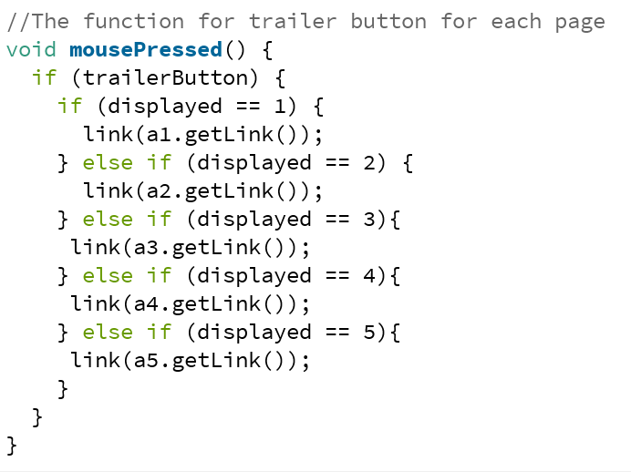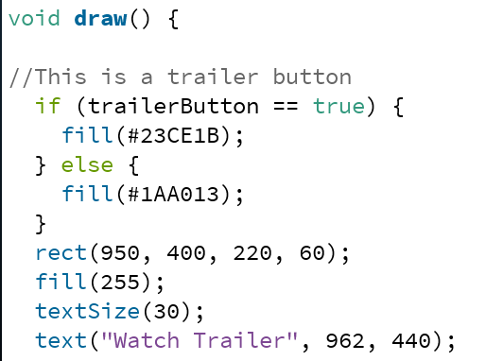

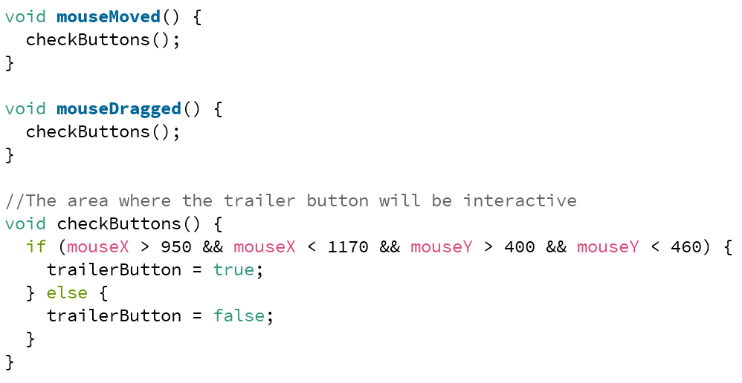

Result

Overall the work that I planned out was great, and basically exactly how I was intending to. There weren’t much issues that I had along, very few really. The progress that I went through I knew majority of the parts that I was going through. In the result things worked out precisely on point.

Conclusion

What I learned after is the way to use classes, and bringing variables to the main set up, and how to implement them. What I would do differently is not so much really because most of the parts worked out the way I intended to, but maybe I would make the variables in some way more efficient if possible, because the way I used them were actually efficient.

Reference

<https://processing.org/examples/embeddedlinks.html>

These are the reference links that helped me get the idea for implementing codes.